PERMIT REVIEW SUMMARY

Permit Writer: Mr. Jaricus Whitlock Date: July 18, 2019

Company Name: Toyota Boshoku Mississippi, LLC

Facility Location: 1 TB Way

Mantachie, MS 38855

Source Number: 1240-00034

County: Itawamba

FACILITY DESCRIPTION

Toyota Boshoku Mississippi, LLC (i.e. “Toyota Boshuku”) is an existing facility that manufactures automotive door trims and interior components. The precise manufacturing process is as follows:

- Polyl, isocyanate, and mold release are mixed and poured into fixed-frame templates (in an automated process) to produce flexible foam used to manufacture cushion components.

- Solid plastic resins are injection-molded to form plastic trim pieces and other components.

- Resins, paints, and solvents are used to fabricate the foam components and trim pieces.
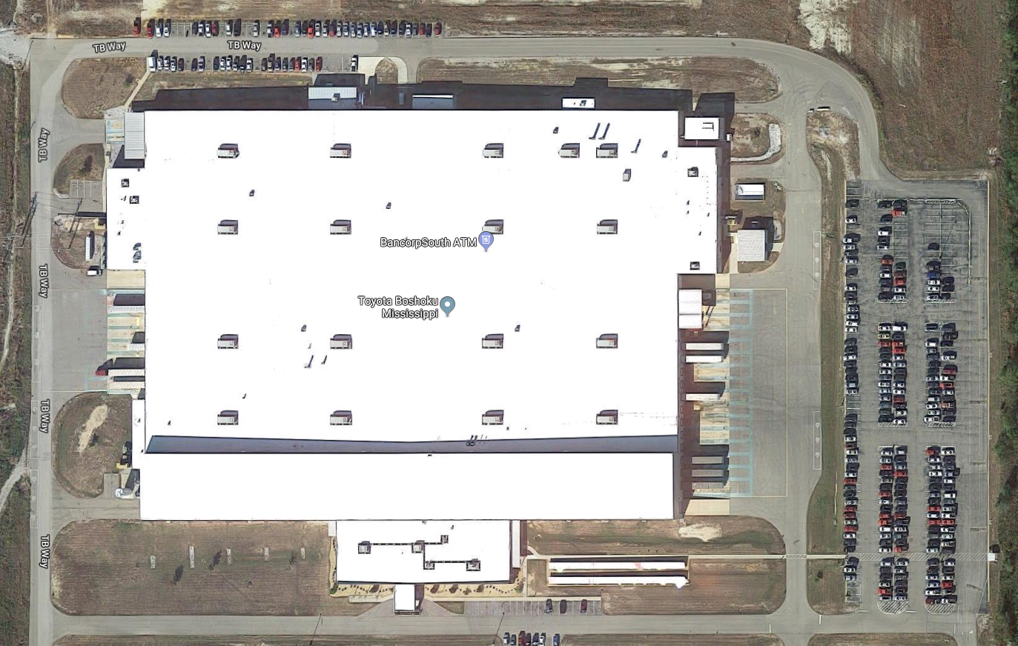

34° 16' 06.5" N
88° 31' 21.7" W

PROJECT DESCRIPTION

Toyota Boshuku is requesting a modification of the existing Synthetic Minor Operating Permit (SMOP) that was initially issued on June 16, 2017 to facilitate both the start-up / operation of an existing spray booth (identified as “150B”) that was previously non-operational and the installation / operation of a new 7,500-gallon methylene diphenyl diisocyante (MDI) storage tank.

The new spray booth will accompany the one (1) spray booth currently operational and collectively encompassed under Emission Point AA-600 (Spray Adhesive Operations). Moreover, the new MDI storage tank will be designated as Emission Point AA-903.

EXPLANATION OF EMISSIONS & SYNTHETIC MINOR LIMITATIONS

Permit Action | VOCs (tpy) | Individual HAP*  (tpy) | Total HAPs  (tpy)
Renewal (2017) | 95.0 | 9.0 | 24.0
Proposed Modification (2019) | 23.13 | 0.72 | 0.72
*Comparison Based on Largest Individual HAP Emitted (Methanol)

The maximum uncontrolled emissions for this proposed modification in addition to the current enforceable emission limits established in the existing SMOP (as shown in the above table) would exceed the Title V threshold for volatile organic compounds (VOCs). Therefore, through this permit modification action, the proposed spray booth and MDI storage tank will be subject to the currently permitted hazardous air pollutant (HAP) emission limitations applicable to the entire facility (i.e. Emission Point AA-000) and the VOC emission limitation applicable to facility-wide coating / cleaning operations, urethane seat foam operations, and spray adhesive operations (i.e. Emission Points AA-200, AA-500, and AA-600) in order to maintain the “synthetic minor source” designation.

All applicable standards (Federal and State) and corresponding monitoring requirements that apply to the proposed spray booth and the MDI storage tank have already been established within the permit. No additional regulations (State or Federal) are applicable to the proposed emission source. Therefore, the only actual modification that made through this permit action to the existing SMOP is denoting that Emission Point AA-600 now has two (2) spray booths and including the 7,500-gallon MDI storage tank as a new emission point.

REGULATORY APPLICABILITY

The following applicable regulations have already been incorporated into the SMOP:

11 MISSISSIPPI ADMINISTRATIVE CODE PART 2, CHAPTER 1

Opacity [11 Miss. Admin. Code Pt. 2. R. 1.3.A. & B.]

- The entire facility is be subject to a State-promulgated opacity limit of 40%. However, the margin of compliance with this limit is expected to be significant given that air pollution control devices (i.e. cartridge dust collectors and dry filters) are being used to minimize particulate matter-based emissions.

Particulate Matter (PM)

- Fossil Fuel Burning [11 Miss. Admin. Code Pt. 2, R. 1.3.D.(1)(a).]

- The existing emergency-based engines (i.e. Emission Points AA-1001a, AA-1001b, and AA-1002) that will utilize diesel as a fuel source and will individually possess a heat input rate less than ten (10) million BTU (MMBTU) per hour. Therefore, the noted engines are subject to a common ash / PM limitation for fossil fuel burning process units (i.e. 0.6 pounds PM per MMBTU).

Sulfur Dioxide (SO₂)

- Fuel Burning [11 Miss. Admin. Code Pt. 2, R. 1.4.A.(1).]

- The existing emergency-based engines (i.e. Emission Points AA-1001a, AA-1001b, and AA-1002) will utilize a fuel to produce power by indirect heat transfer. Therefore, both units are subject to a specific SO₂ emission rate limitation (i.e. 4.8 pounds SO₂ per MMBTU).

NSPS APPPLICABILITY

40 CFR Part 60, Subpart IIII – Standards of Performance for Stationary Compression Ignition Combustion Engines

- As the existing emergency engines are compression-ignition, internal combustion engines and are individually manufactured after the effective date of April 1, 2006, Toyota Boshuku is subject to this subpart As such, each emergency engine must adhere to applicable emission standards for certain pollutants: Non-Methane Hydrocarbons + Nitrogen Oxides (NMHC + NO_{X}); carbon monoxide (CO); particulate matter (PM); Opacity (Smoke).

- Additionally, the diesel fuel to be utilized in each emergency engine must comply with applicable fuel standards.

MACT APPLICABILITY

40 CFR Part 63, Subpart ZZZZ - National Emissions Standards for Hazardous Air Pollutants for Stationary Reciprocating Internal Combustion Engines

Based on the specifications of the existing emergency engines, the facility is subject to this subpart. However, by complying the applicable requirements of 40 CFR Part 60, 40 CFR Part 60, Subpart IIII – Standards of Performance for Stationary Compression Ignition Internal Combustion Engines, Toyota Boshuku shall also demonstrate compliance with Subpart ZZZZ.

40 CFR Part 63, Subpart OOOOOO – National Emission Standards for Hazardous Air Pollutants for Flexible Polyurethane Foam Production and Fabrication Area Sources

- Emission Point AA-500 (Urethane Seat Foam Operations) is a molded flexible polyurethane foam production operation and Emission Point AA-600 Spray Adhesive Operations) a flexible polyurethane foam fabrication operation. Moreover, Toyota Boshuku is an area source for hazardous air pollutants (HAPs) (i.e. emits less than 25.0 tpy of all combined HAPs and emits less than 10.0 tpy of any individual HAP). As such, the noted emission points are subject to and shall comply with all applicable requirements of this subpart.

APPLICABLE PERMIT LIMITATIONS

Emission  Point | Pollutant(s) /  Parameter(s) | Applicable Requirement(s) | Limitation(s) / Standard(s) | Monitoring Requirement(s)
AA-000 | Opacity | 11 Miss. Admin. Code Pt. 2, R. 1.3.A.  11 Miss. Admin. Code Pt. 2, R. 1.3.B. | 40% | The margin of compliance is expected to be significant given that air pollution control devices are used to minimize particulate matter-based emissions.
 | HAPs | 11 Miss. Admin. Code Pt. 2, R. 2.2.B.(10). | 9.0 tpy (Individual)  24.0 tpy (Total)  (Major Source Avoidance Limit) | The facility will record and maintain the monthly usage of materials that contain HAPs on a monthly basis and over a rolling 12-month period (in addition to the HAP-content percentage).
AA-200  AA-500  AA-600 | HAPs | 11 Miss. Admin. Code Pt. 2, R. 2.2.B.(10). | 95.0 tpy (Total)  (Major Source Avoidance Limit) | The facility will record and maintain the monthly usage of materials that contain VOCs on a monthly basis and over a rolling 12-month period (in addition to the VOC-content percentage).

PUBLIC PARTICIPATION

The 30-day public notice period will begin on July 24, 2019 and end on August 26, 2019 with a copy of the notice being published in the Itawamba County Times.

RECOMMENDATION

The staff has preliminarily decided to recommend issuance of the permit to the Mississippi Environmental Quality Permit Board as shown in the draft permit. However, the staff recommendation to the Board will be made only after a thorough consideration of all public comments.

